**Stack and Unstack Homework - The Big Reversal**

Dr. Bergen[1] is at it again! He had a follow-up meeting with his client and it was determined that we need to redo the file construction from an earlier assignment. Recall that the file **health_survey.csv** contains the responses to a series of health-related questions and we coded the responses as 1-5 using the definition below. It turns out that some of the columns need a reverse coding (see the *Needs Reverse Coding?* column in **ReverseCodingItems.csv**.

|  |  |  |
| --- | --- | --- |
| Old Label | New Coded Value | Reverse Coding |
| “Strongly Disagree” | 1 | 5 |
| “Somewhat Disagree” | 2 | 4 |
| “Neither Agree nor Disagree” | 3 | 3 |
| “Somewhat Agree” | 4 | 2 |
| “Strongly Agree” | 5 | 1 |

1. Look at the questions that need reverse coding and explain why it makes sense to reverse the coding on these items.
2. You will need to redo the file construction, but now need to take the reverse coding into account. **For each step, paste a screenshot of the JMP dialog or formula associated with the outcome.**
   1. *Stack* the columns.

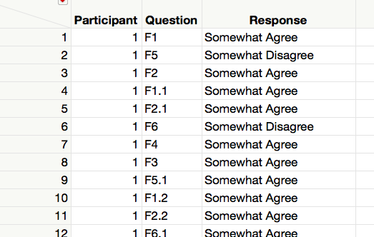

**JMP screenshot:**

* 1. Make a new column called *Needs Reverse* by *Recoding* the Question Identifier to “Yes” or “No” per the *Needs Reverse Coding?* column in **ReverseCodingItems.csv.**

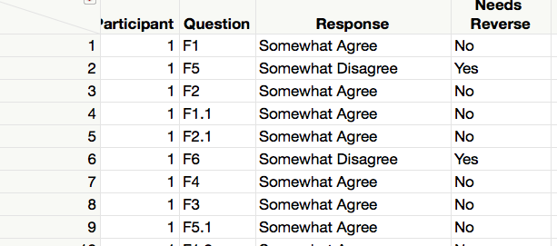

**JMP screenshot:**

* 1. Make a new column called *Temp Coded Value* by *Recoding* the Questions Responses to the New Coded Values.

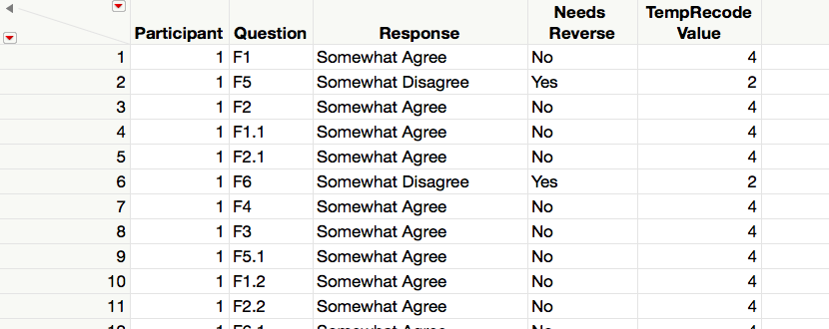

**JMP screenshot:**

* 1. Make a new column called *Temp Coded Value* by *Recoding* the Questions Responses to the Reversed Coded Values.

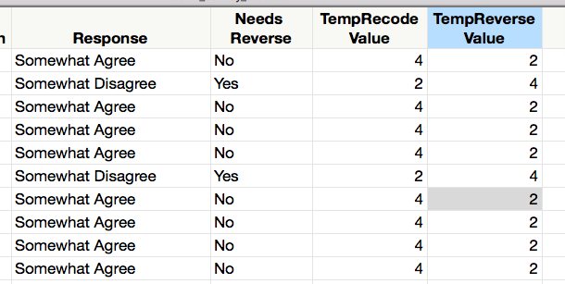

**JMP screenshot:**

* 1. Make a new column called *Recoded Value* that holds the correct value for each question. You will want to use an MATCH statement and use *Needs Reverse* to decide which temporary value to use.

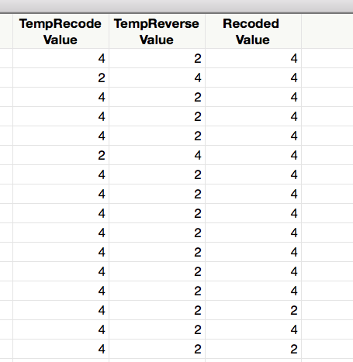

**JMP screenshot:**

* 1. Make a new column by *Recoding* the Question Types to *F1, F2, …, F6.*

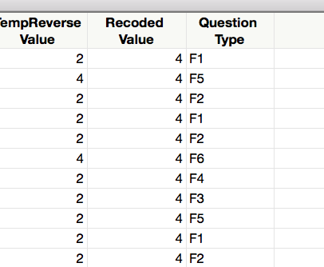

**JMP screenshot:**

* 1. *Aggregate* and *Split.*

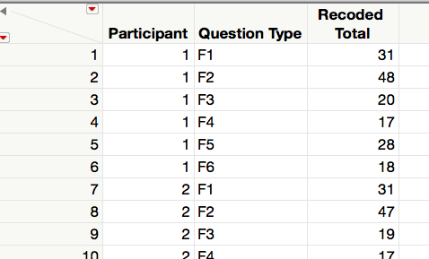 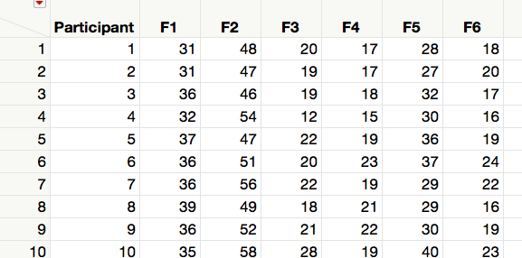

**JMP screenshot:**

1. Submit this document with your answer to question 1 and a csv file with your final table.

1. Director of the Statistical Consulting Center at Winona State University